Gordon Elliott Williams
BIA530 30 Business Performance Management

Solo Response to #9.

Comparison of Distributions

Upon comparing the distributions of pounds sold per week with the number of daily visits to the QA website, we can observe notable differences in their normality.

Pounds Sold Per Week:
- The histogram for pounds sold per week (from the previous task) is roughly bell-shaped and relatively symmetrical, indicating an approximately normal distribution.
- The mean and median are close in value, which is another characteristic of a normal distribution.
- The Empirical Rule calculations show a good fit between theoretical and actual observations within one and two standard deviations of the mean, further supporting the assumption of normality.

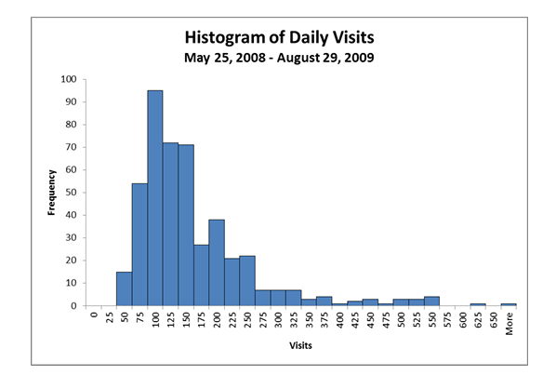

Daily Visits to QA Website:
- In contrast, the histogram for daily visits is significantly skewed to the right, demonstrating a non-normal distribution. The majority of the data points are clustered on the lower end, with a long tail extending towards higher values.
- The mean (151) is substantially larger than the median (133), which is typical for a right-skewed distribution.

Conclusion
Based on these observations, the distribution of pounds sold per week is much closer to a normal distribution than the number of daily visits to the QA website. The daily visits data exhibits a pronounced right skewness, violating the assumptions of normality. This difference in distribution shapes is crucial to consider when performing further statistical analyses, as certain methods assume normality, and using them on non-normal data may lead to inaccurate conclusions. The daily visits data may benefit from a transformation (such as a logarithmic transformation) to improve its symmetry to normality before applying certain statistical techniques.

